Db in class assignment
Vaijayanti Deshmukh
- Create an EC2 instance
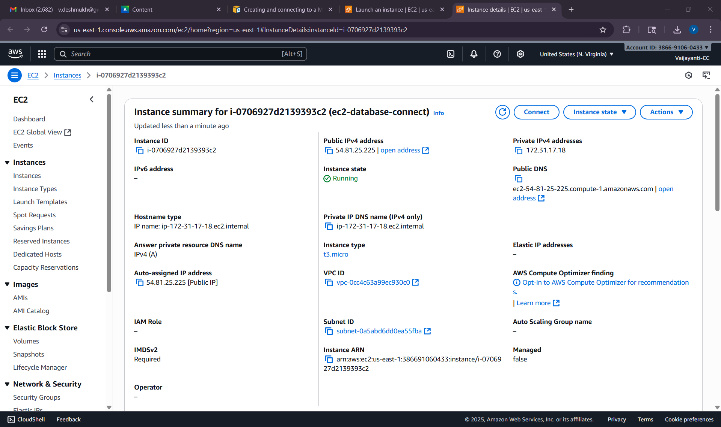
- Create a MariaDB instance
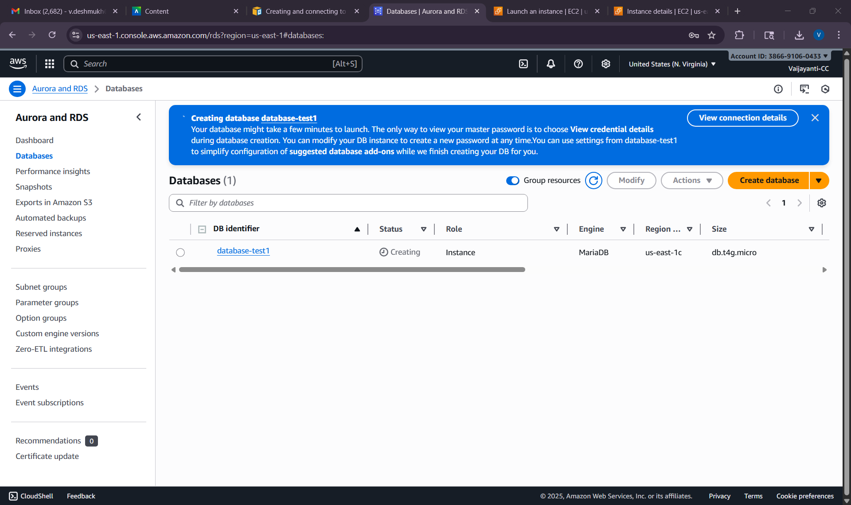
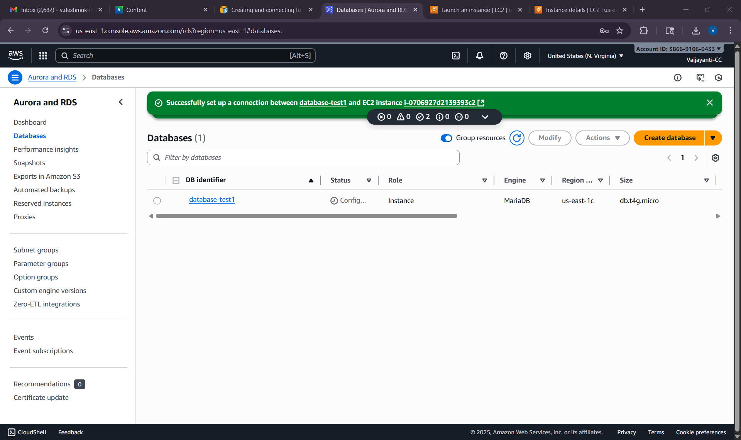
Master username : admin
Endpoint : database-test1.cetu4e24atk6.us-east-1.rds.amazonaws.com
- Connect to a MariaDB instance
